4 October 2011
Dr. Bradley J. Butterfield
Merriam-Powell Center for Environmental Research
NAU Box 6077
Northern Arizona University
Flagstaff Arizona 86011
RE: Manuscript1213414

Dear Dr. Zahn,
Thank you for handling our manuscript “Evolutionary history limits convergence of alpine plant communities across five continents” for Science. After receiving the reviews, we are seriously concerned that our manuscript was not given the appropriate level and quality of scrutiny that we expected. Both reviewers make statements that indicate both cursory readings of our manuscript as well as serious mistakes in the interpretation of our methods and results. Furthermore, they take no issue with (and appreciate) the primary finding of our work, only providing unsubstantiated criticisms of supporting aspects of our research. Because we believe that the decision to reject our manuscript was not based on a thorough understanding of our approach, and consequently that the MS is both scientifically sound and containing results of genuine significance, we have undertaken minor revisions based on the few substantive comments provided by the reviewers, and have also provided additional analysis that supports our chosen methods and results.
Given the serious mistakes made in the initial reviews, we respectfully ask you to consider a resubmission and review of our manuscript. We believe that this work is of high quality and importance, and hope that the effort put in to developing this manuscript will be matched by that of its reviews.
Sincerely,
Brad Butterfield and colleagues

************************
Reviewer 1
The strength of this work lies in the impressive amount of data that have been assembled to detect phylogenetic patterns in alpine plant communities. The analyses performed using these data, however, are not completely convincing, for two main reasons: (1) some of the methods
used and the way they are interpreted are questionable, and (2) the manuscript is often obscured by a vague, convoluted writing style.
My main concern with the methods lies in the use and interpretation of the “relative interaction intensity” index (RII). This index was devised to compare the mass of isolated plants with neighbours removed to control plants with neighbours left intact in an experimental setting. Here, RII is used to quantify the “microhabitat preference” of different species in a non-experimental setting. But microhabitat preferences have nothing to do with species interactions. In fact, the effect of microhabitat preferences should be removed to assess the sign and magnitude of species interactions since these interactions take place within the context of given preferences. Therefore, the interpretation of RII in terms of competition and facilitation that
permeates the manuscript is unwarranted.
This criticism is unclear: however, we see two possible ways in which it can be interpreted, both of which can be refuted. First, the reviewer may be confusing interactions between cushion and non-cushion species (the way in which we measured RII) with interactions among non-cushion species. Having carefully considered the description of our application of RII as provided in the MS, we are unfortunately forced to conclude that this criticism can only result from a cursory assessment of the manuscript. Second, the reviewer may object to the use of static spatial patterns to infer biotic interactions. Such an approach has been used many times in the study of biotic interactions, demonstrating a link between spatial pattern and underlying process particularly in alpine environments (see Choler et al. 2001, Olofsson 2004, Kikvidze et al. 2005, Dullinger et al. 2007), and has been strongly supported by manipulative experiments in communities included in our dataset (Michalet et al. 2011).
Other potential methodological issues include the following:
1. Using Phylomatic to create a master phylogeny is a cheap way to obtain a rather poor phylogeny.
This statement is incorrect. Phylomatic is a common approach used in many recent well-regarded studies of community phylogenetics (e.g. Bryant et al. 2008, Valiente-Banuet and Verdú 2007, Wright et al. 2007). More importantly with respect to the scientific quality of our conclusions, phylogenies derived in this way provide similar results to more resolved phylogenies (Cavender-Bares et al. 2006). Furthermore, when the phylogeny considered includes the entire breadth of angiosperm evolutionary history (as in our study), small differences in the relationships among taxa at the tips of the phylogeny should have no effect on patterns assessed at a scale of more than 160 million years of evolutionary history. We therefore consider this criticism to be unfounded.
2. Randomly breaking polytomies tends to bias estimates of Blomberg’s K statistic.
This is an unsubstantiated criticism with no theoretical foundation. Since all genera across the phylogeny were treated with the same procedure, any possible effect on the estimate of K would have a mean value of zero at the scale of the whole phylogeny (i.e. when calculating this value across many sub-clades). In fact, this procedure would reduce the probability of finding a significant phylogenetic signal since the observed variances in the phylogenetic independent contrasts (PICs) may be inflated by reducing the denominator (branch length) in the calculation of PICs. Consequently we find a significant phylogenetic signal in the non-cushion phylogeny despite applying a relatively conservative analytical approach which reduces our chances of finding a significant relationship: this is the exact opposite of the criticism raised here.
3. Testing for a phylogenetic signal in the frequency of cushion species per family (lines 150-151) implicitly assumes that the frequency of cushion species per family is a species-level trait subject to evolution, which is questionable.
If certain ancestral states (e.g. woodiness, phyllotaxy, growth form) increase the probability of evolving a complex character state which we refer to as “cushion”, then there is certainly reason to expect that certain clades may be more likely to evolve proportionally more cushion species than others. This test allows us to contrast the likelihood that the number of cushion species in a given area is a function of evolutionary versus biogeographic history.
The statements made in the manuscript are also often difficult to decipher because they are too vague or general. Examples include the sentences in lines 72-76 (abstract), 151-154, 195-197, and 207-212. These statements could probably be interpreted in many different ways by
different persons.
We have addressed this criticism by clarifying the identified statements in the manuscript.
The real novelty of this contribution may lie in the finding that variation in phylogenetic patterns “may be explained by the phylogenetic distance between dominant species and their neighbours” (lines 164-165). The generalisation of this finding to other communities (lines 213-215), however, is speculative at this stage. In contrast, other results, in particular those from the biogeographic analyses reported in Fig. 4, are hardly surprising and do not bring any major new insights; they could easily be removed.
We empirically demonstrate a heretofore untested role of evolutionary history in shaping plant community diversity and structure across 5 continents. Thus we strongly disagree with the referee’s statement, and feel that is clearly a scientifically important contribution on its own. Furthermore, the biogeographic analyses demonstrate that this pattern holds across continents with very different evolutionary histories and clade representations, lending further support to the generality of our findings.
************************
Reviewer 2
This manuscript deals with the effects of evolutionary history in the outcome of plant-plant interactions across 77 alpine communities worldwide. The topic is interesting and the database quite impressive but the conclusions of the paper cannot be supported by the analyses
because they are seriously flawed.
The first mistake is to confound K<1 with a lack of trait conservatism (lines 132-135). The authors calculate the phylogenetic signal of non-cushion species’ responses to cushion plants and found a significant K value (K=0.15, P<0.001). They interpret this result in the following form: "if a species was found primarily in cushion plants then individuals of its nearest relative were likely to be found primarily in the open". This is not true. A significant K value means that closely related species tend to resemble each other more than expected by chance. This is because the statistical test has the null hypothesis of K=0 (and not that of K=1). When K<1, but significant, the interpretation is that the phylogenetic signal exists althoug it is weaker than
expected under a Brownian Motion evolutionary model.
The reviewer incorrectly interprets both the meaning of the K-statistic, as well as the statistical test upon which the P-value is based. First, Ackerly (2009, p. 19701) states that “K<1 is a low phylogenetic signal, meaning that closely related species are more different from each other than expected (compared with the differences that have accumulated among distant relatives)…” This is in line with our interpretation. Second, while K~1 indicates Brownian-Motion trait evolution, which may be treated as a null evolutionary expectation, it is not the null statistical hypothesis upon which a test of significant phylogenetic signal is based. A significant phylogenetic signal exists if the observed variance of phylogenetic independent contrasts is less than the expected variance based on randomization tests (Blomberg et al. 2003, Kembel et al. 2010); in our case, the null hypothesis was unlikely (P<0.001). Thus, the value of the K-statistic is not statistically compared to a null expectation of K~1. The utility of the K-statistic is that it is comparable across any traits or phylogenies, and could be compared to the universe of K-values thusfar observed across all studies, or studies assessing similar traits. We believe these distinctions are clear in the Methods section of our manuscript. Nevertheless, we have provided an additional section to the Supporting Online Material that further elaborates on this issue, as well as the following potential “bias” in our use of Pagel’s delta (see below).
The second mistake is to calculate Pagel´s delta as a measure of the the evolutionary tempo in a phylogeny where polytomies have been randomly resolved and infinitesimal branch length assigned. By doing so you are indicating that bursts of speciation have occurred in the clades with polytomies. As polytomic nodes tend to be towards the tips because the deep evolutionary angiosperm relationships are well established by the angiosperm phylogeny used by phylomatic, then these bursts of speciaction are placed towards recent times. Consequently, Pagel´s delta necessarily estimates that variation in evolutionary responses are associated with recent evolutionary events. But this is a mere artifact of the polytomy resolution method used. To properly apply Pagel´s delta, it is necessary to know very well both the topology and the chronology of the tree at the species level.
Aside from the issue that the “true” branch lengths among congeners are likely to be very small relative to the branch lengths across families and orders included in our community phylogenies, there could be some impact of polytomies on calculating Pagel’s delta. We have now included a comparison of observed changes in phylogenetic independent contrasts with node depth versus simulated patterns based on a set of approximately Brownian-Motion models of trait evolution generated by randomly assigning traits to the tips of the observed phylogeny. Thus, any effects of our method of resolving polytomies should also be apparent in the simulated “null” trait evolution models. Such a “bias” is not found: simulated B-M PIC estimates are generally constant with node depth, and the observed dramatic increase in PICs toward the tips of the phylogeny differs quite significantly from these null models. This result is now included as Fig. S2, and also at the bottom of this letter.
The paper introduces the fact that nurse effects in alpine communities varies across communities (l. 96-99) and that these variations can be due to differences in evolutionary history. However, the analyses do not address the relative contribution of (or the interaction between) evolutionary history vs. environmental variables across communities. Both factors can be simultaneously affecting the outcome of plant-plant interactions.
This is absolutely false. We state in the Methods that we conducted the same tests after accounting for variation in plant cover (a surrogate for productivity, which was the best predictor of biotic interactions from among a suite of variables, including downscaled climatic variables), and found no qualitative differences. All results are (and were) presented in Tables S3&4. A sentence has been added in the main text to reflect this.
In summary, I find that this is a good pilot study but it is still too far to provide convincing general conclusions.
Our work represents over three years of data collection from sites throughout the world and represents one of the largest data sets yet accumulated for integrating evolutionary history with community ecology. As stated, we believe that the analyses are sound, and that the criticisms of both referees are therefore unfounded. Far from being a pilot study this is a substantial and thorough piece of work with wide-reaching implications.

References

Ackerly D. 2009. Conservatism and diversification of plant functional traits: Evolutionary rates versus phylogenetic signal. PNAS 106: 19699-19706.
Blomberg SP, Garland T, Ives AR. 2003. Testing for phylogenetic signal in comparative data: Behavioral traits are more labile. Evolution 57: 717-745.
Bryant JA, Lamanna C, Morlon H, Kerkhoff AJ, Enquist BJ, Green JL. 2008. Microbes on mountainsides: Contrasting elevational patterns of bacterial and plant diversity. PNAS 105: 11505-11511.
Cavender-Bares J, Keen A, Miles B. 2006. Phylogenetic structure of Floridian plant communities depends on taxonomic and spatial scale. Ecology 87: S109-S122.
Choler P, Michalet R, Callaway RM. 2001. Facilitation and competition on gradients in alpine plant communities. Ecology 82: 3295-3308.
Dullinger S, et al. 2007. Weak and variable relationships between environmental severity and small-scale co-occurrence in alpine plant communities. J. Ecology 95: 1284-1295.
Kembel SW, et al. 2010. Picante: R tools for integrating phylogenies and ecology. Bioinformatics 26: 1463-1464.
Kikvidze Z, Pugnaire FI, Brooker RW, Choler P, Lortie CJ, Michalet R, Callaway RM. 2005. Linking patterns and processes in alpine plant communities: A global study. Ecology 86: 1395-1400.
Michalet R, Xiao S, Touzard B, Smith DS, Cavieres LA, Callaway RM, Whitham TG. 2011. Phenotypic variation in nurse traits and community feedbacks define an alpine community. Ecology Letters 14: 433-443.
Olofsson J. 2004. Positive and negative plant-plant interactions in two contrasting arctic-alpine plant communities. AAAR 36: 464-467.
Valiente-Banuet A, Verdú M. 2007. Facilitation can increase the phylogenetic diversity of plant communities. Ecology Letters 10: 1029-1036.
Wright I, et al. 2007. Relationships among ecologically important dimensions of plant trait variation across seven neotropical forests. Annals of Botany 99: 1003-1015.

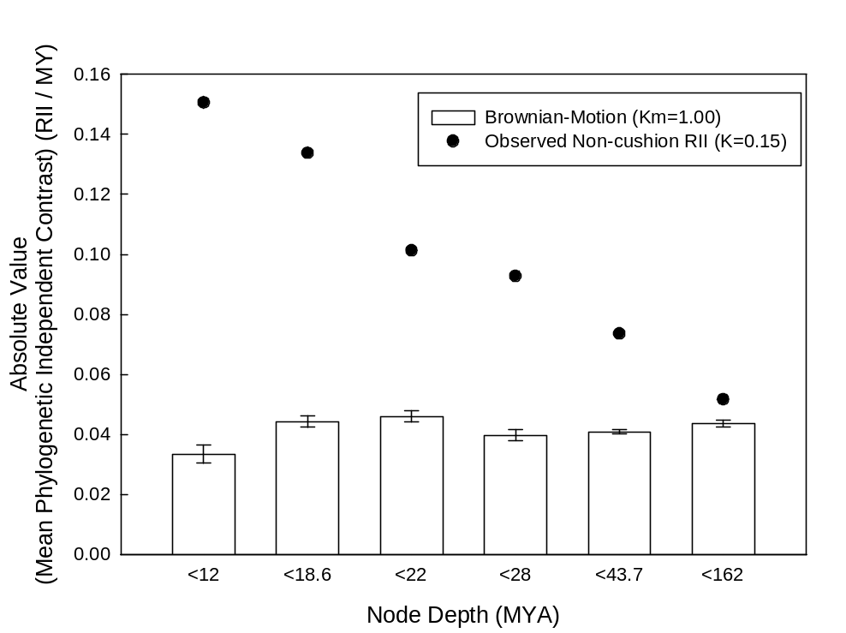
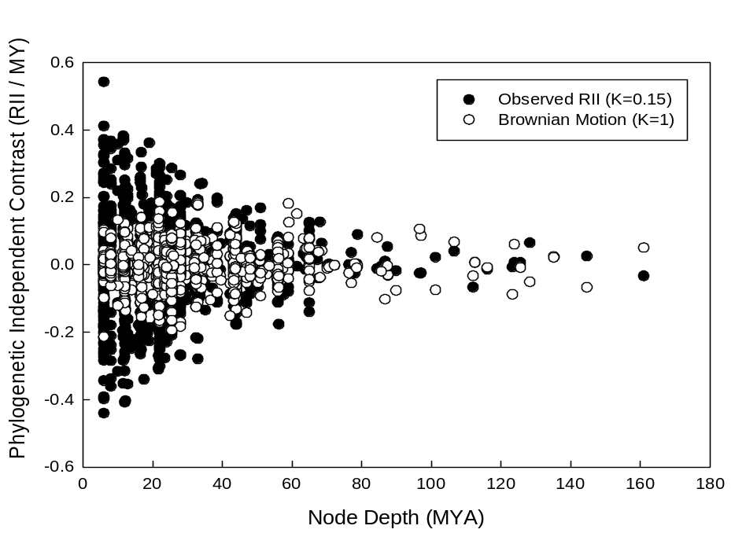
Fig. S2. Phylogenetic independent contrasts in non-cushion RII as a function of node depth. In the top panel, mean absolute values of PICs from the observed data are compared to mean +/- 1SE for a set of null models with approximately Brownian-Motion trait evolution (n=14, 0.9<K<1.1), generated by randomly assigning trait values to the observed non-cushion phylogeny. In the bottom panel, the observed PICs are plotted versus a single null model (K=1). Both results correspond with the high estimated value of Pagel’s delta (δ), indicating more substantial trait evolution associated with recent evolutionary events.

